Guide to add and edit content on the Project page

1. Go to the ADM Dashboard

<https://infinitaproductions.com/admin/wp-admin/>

Login with your username and password.

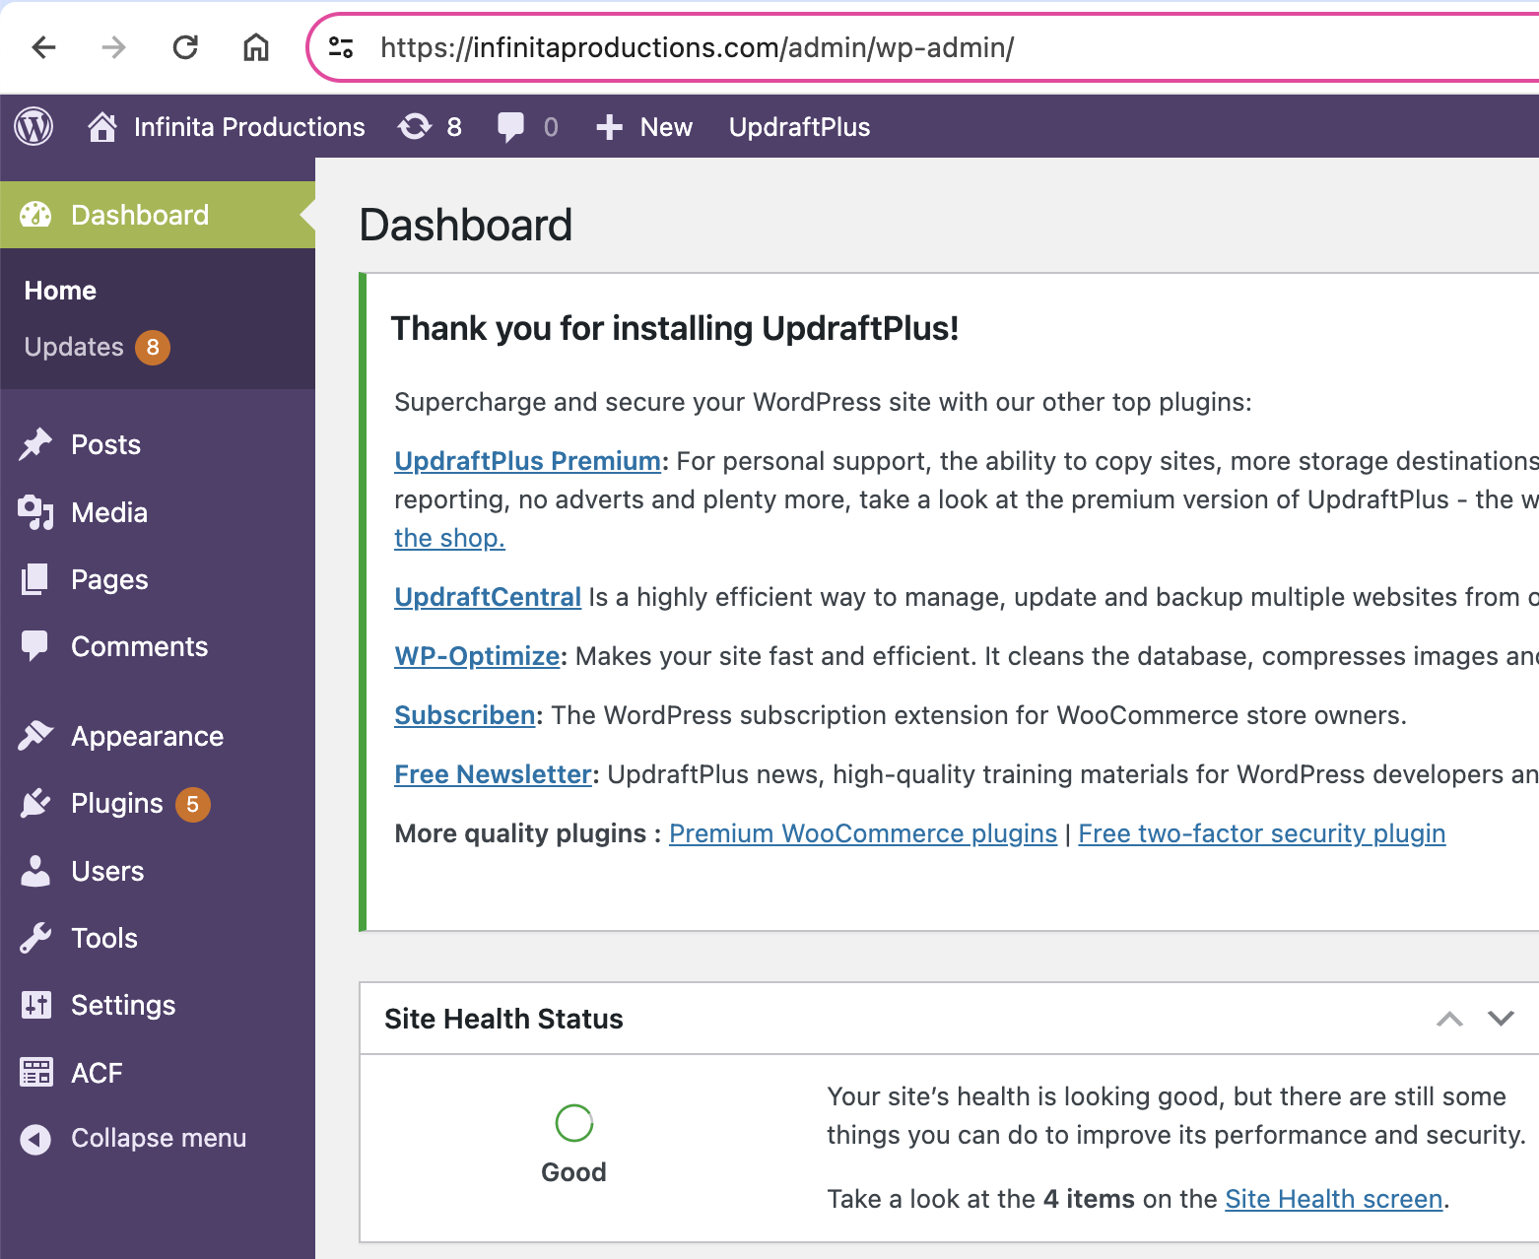

**PROJECT**

Each project is presented as a post on WordPress.  
To edit existing content go to “Posts”choose the project you want to edit and edit the filds with the same intrunctions af crete a new project :   
  
**To add new content:**

1. Go to Posts:  
   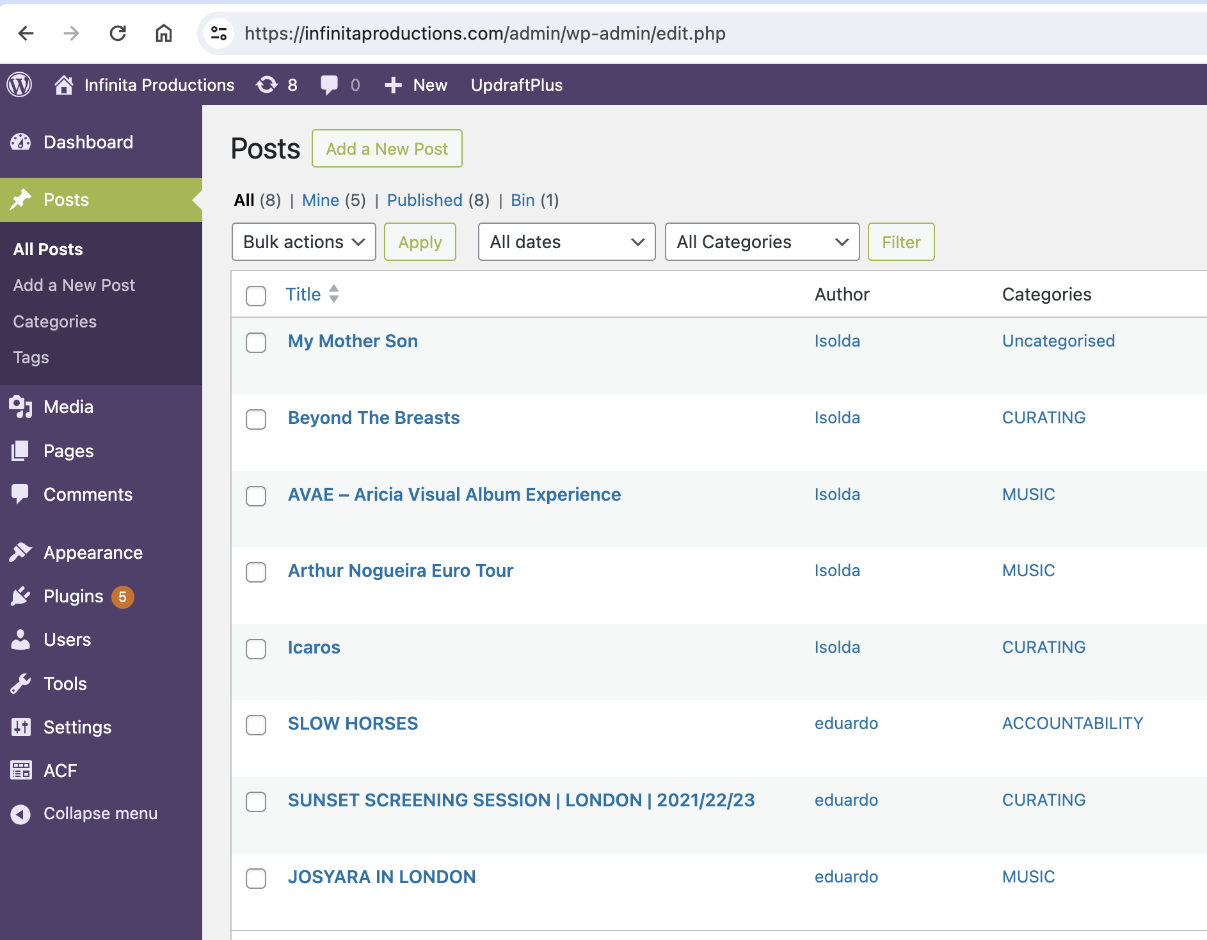
2. Click add a New Post



This screen will open:

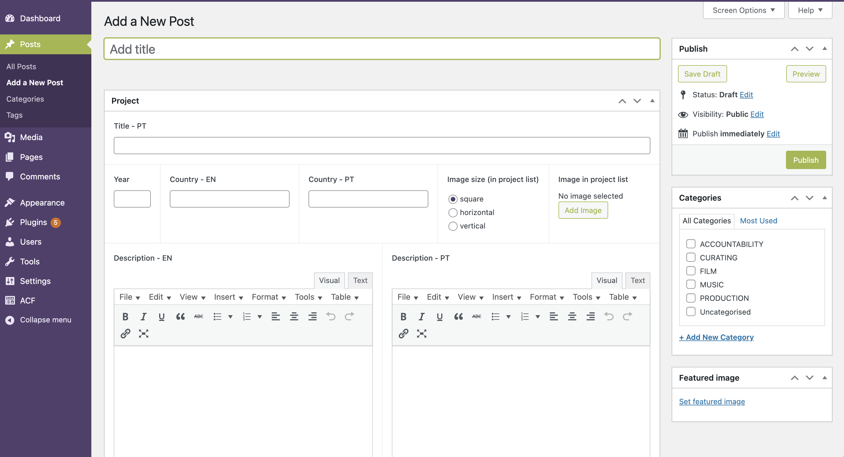

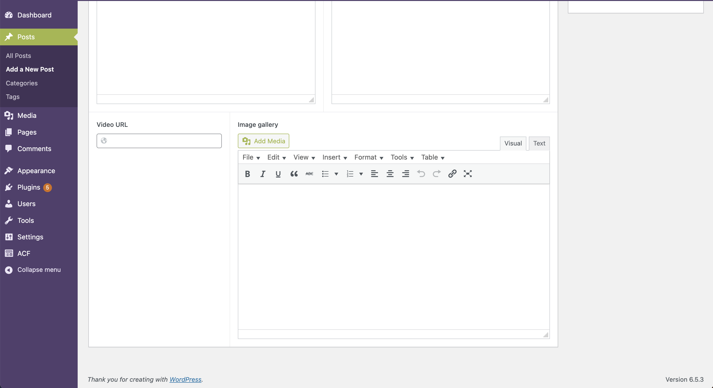

Important note:

A new project will be showed on the website just if you add an image for the Grid. The field for the it is “Image in project list” in the new Post.

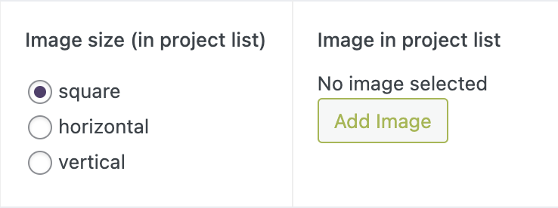

1. Filling in project content:
2. English Title



1. Portuguese Title



1. Year





1. Country in English



1. Country in English

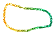

1. Select if you want square, horizontal or vertical image in the projects’ images grid



1. Adding an image to the Grid in projects page.   
   Go to Image Project List. Click Add Image.

  
  
  
Set the grid’s image.   
Select an image from the media library if the image is already there. Or…  
 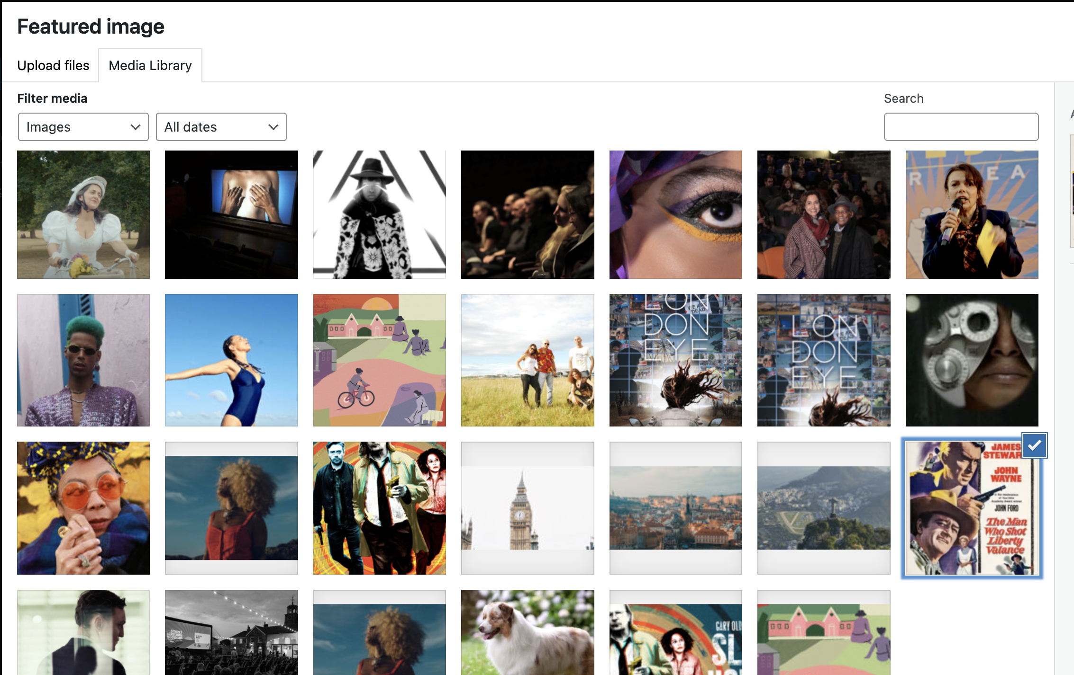  
  
- Go to upload files.   
- Drop or select an image (maximum 256 MB ) and   
- Set featured image.



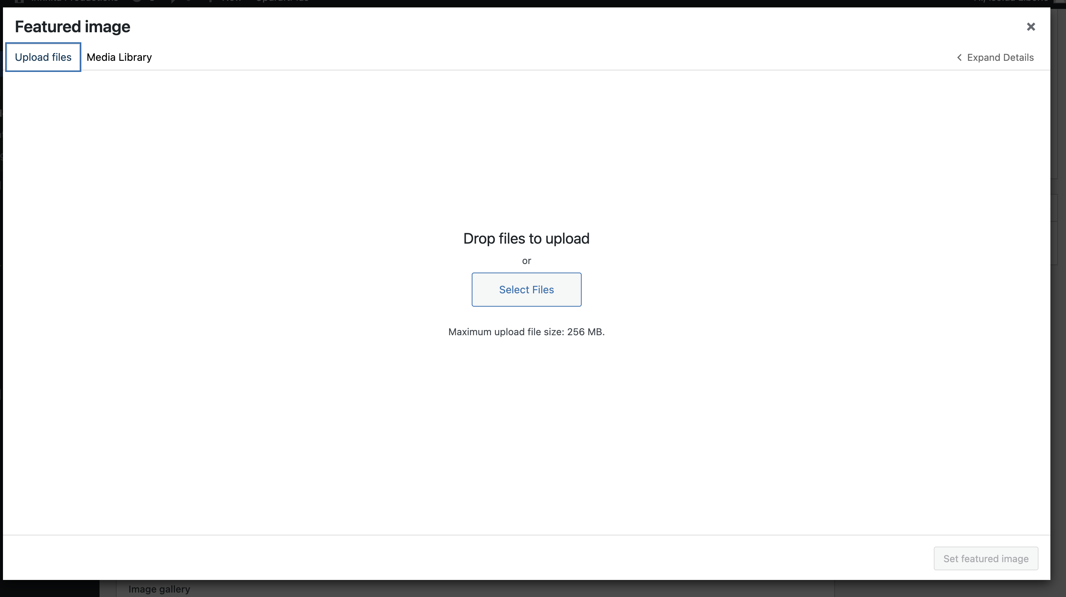

1. Add the Inner project page image/poster.  
   Go to Featured Image > Set featured image  
     
     
   Select one image in the media library if the image is already there And Set featured Image.   
     
   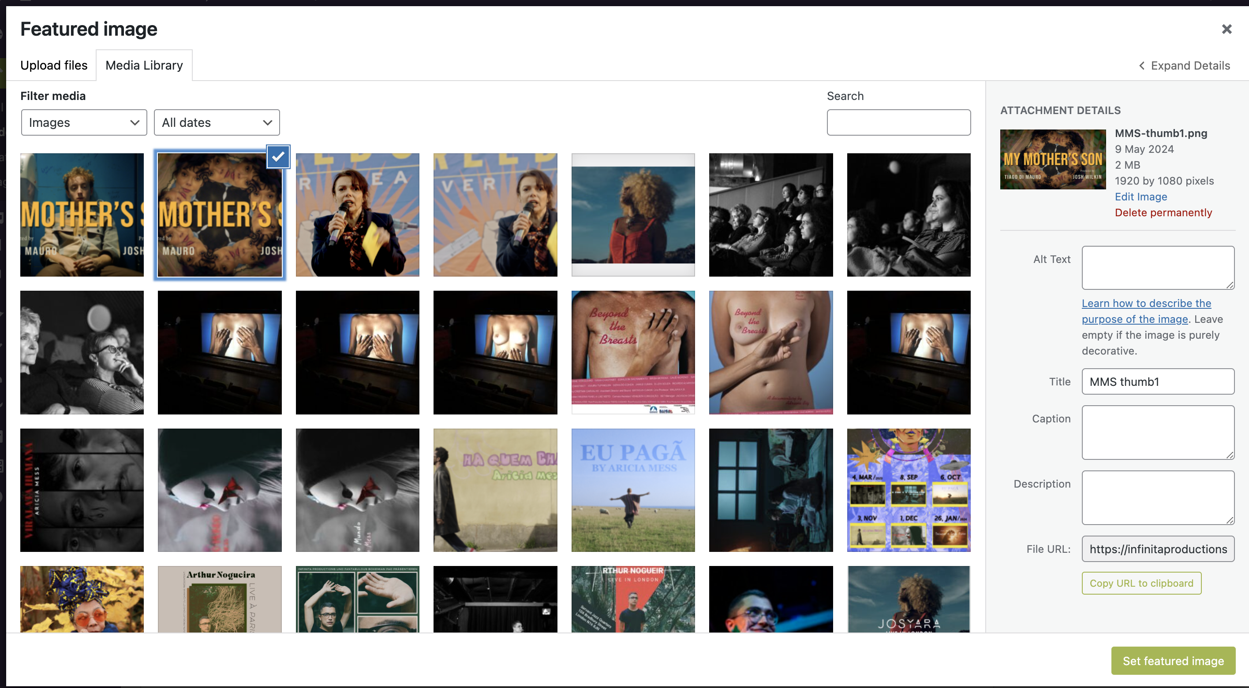  
     
   Or   
   - go to upload files.   
   - Drop or select an image (maximum 256 MB ) and  
   - Set featured image.



1. Assign a category to the project.   
   Note:   
   - keep the Uncategorised unselected.   
   - Note if no category is selected it will be select on the Uncategorised and the project will not apear in any filter.

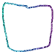

* On the development we authomitezed the visualization of new categories on the website. So if you create a new category and use it for a new posts, it will automatically be added to the site. But note that the design and layout implemented was created for displaying the 5 categories existents.   
    
  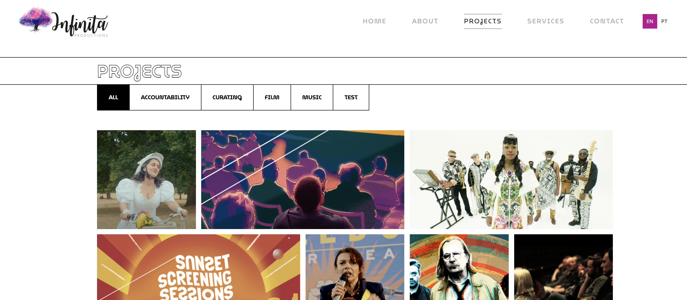

1. Add the project description (and credits).   
   English in left box / Portuguese in right box.  
   Note:   
   - To give a line break you need to keep the text in the same line and press shift+enter. Be aware that if you copy and paste text sometimes you will need to delete the lines and create it again for the text to be formatted properly.

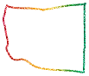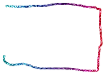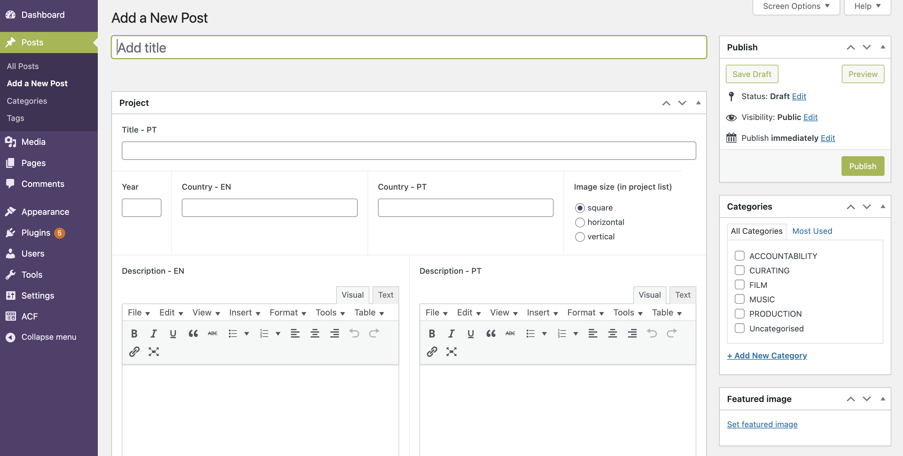



1. Embeded Video.

- Add the link for the embeded video (youtube or vimeo) in the Video URL field.   


1. Image Gallery (on the inner project page):

* Click on add media



* Click Create gallery
  + Upload a New file (if the images aren’t in the media gallery already)
  + Drop the images for your gallery
  + Create a new gallery

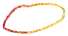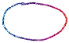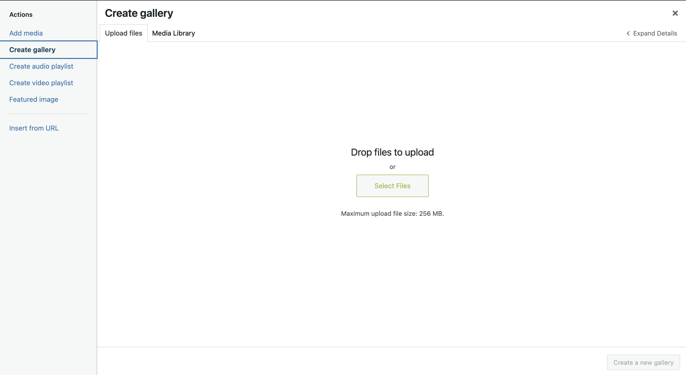

Then on the gallery settings (right hand side ):

* In link to: select media file
* In size: select Large
* Click in insert gallery  
    
  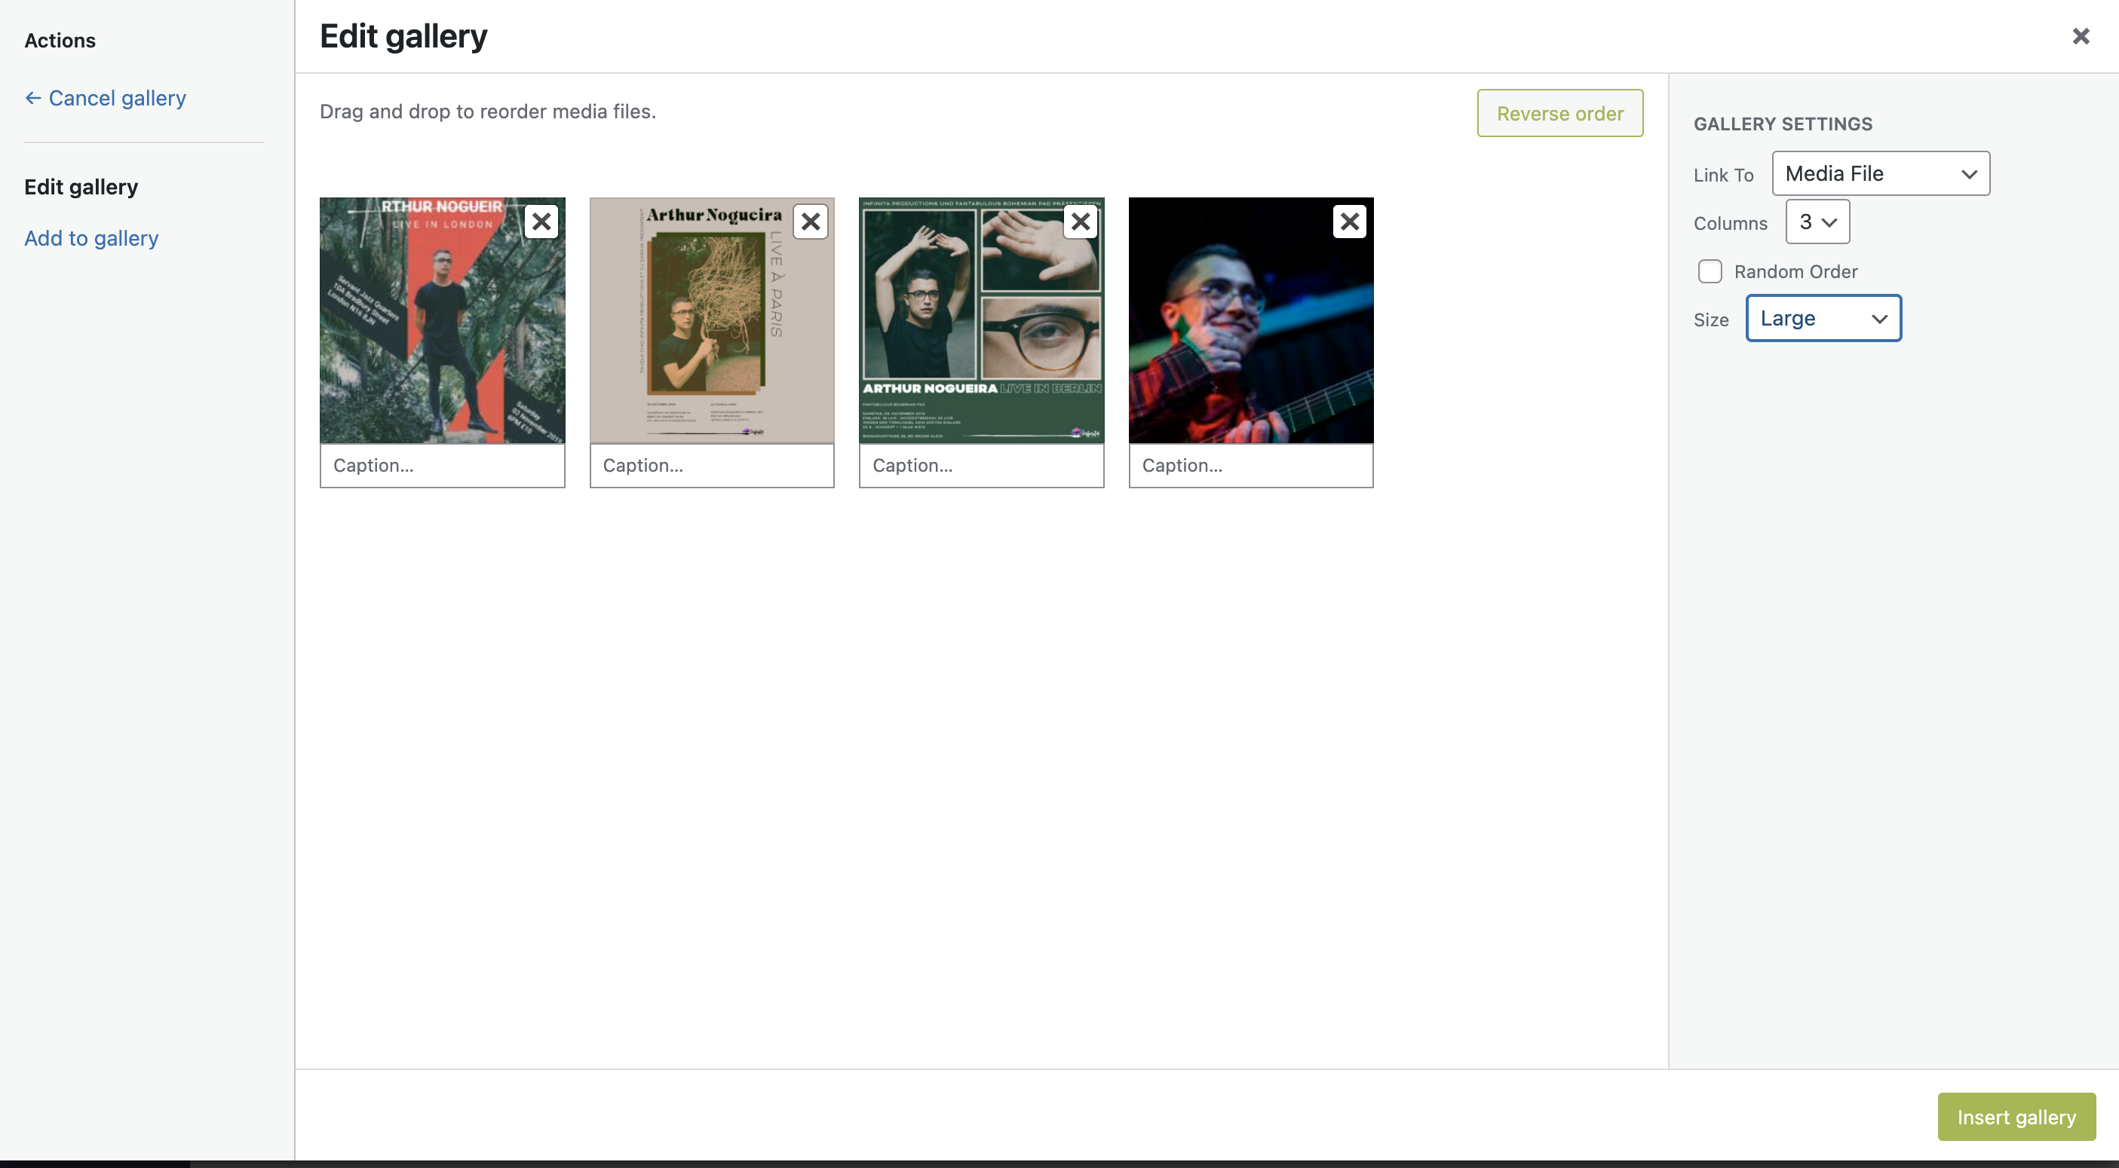

- If the image is already in the media library, select the images you want there.

